PYTHON CAFE
MANAGEMENT SYSTEM
Project Report
Project Type | Python Console Application
Database / Storage | JSON files
Prepared By | Pratyush Shukla || registration no = 26BCE11174
Course / Section | cse
A simple cafe billing and menu-management system with customer ordering, admin controls, JSON storage and sales reporting.

Cover Page
The cover page identifies the project as the Python Cafe Management System. The application is a menu, ordering, billing and sales-report system developed as a Python console project.

Introduction
The Python Cafe Management System is designed for a small cafe that needs a simple way to display menu items, take customer orders, calculate GST, generate a bill, manage menu prices and view sales information. The project uses Python functions and JSON files instead of a large database, keeping the implementation easy to understand and suitable for an academic project.

Problem Statement
Manual cafe billing can lead to calculation mistakes, repeated work and difficulty in maintaining menu prices or sales records. The proposed system provides a single console-based application where menu data, customer orders, billing calculations and sales summaries can be handled in a structured way.

Project Objectives
- Display the current cafe menu with item names and prices.
- Accept item numbers and quantities from a customer.
- Calculate subtotal, 5% GST and final total automatically.
- Generate a numbered bill with date and customer name.
- Allow an administrator to add, change or remove menu items.
- Store menu and order information in JSON files so data can continue between runs.
- Generate a sales report showing total orders, revenue and items sold.

Functional Requirements
ID | Requirement | Description
FR1 | View Menu | Display all available items and prices.
FR2 | Take Order | Accept item number and quantity until the customer finishes.
FR3 | Billing | Calculate subtotal, GST and total and print a bill.
FR4 | Admin Login | Protect menu-management functions with a password.
FR5 | Menu Management | Add, change price and remove menu items.
FR6 | Sales Report | Show order count, revenue and quantity sold.
FR7 | Data Persistence | Save and load menu and order records using JSON.

Non-functional Requirements
Category | Requirement
Usability | Simple numbered console menus and clear messages.
Reliability | Validate item numbers, quantities and prices; handle invalid JSON reads.
Maintainability | Use separate functions for menu, order, billing, admin and reporting.
Performance | Suitable for a small number of menu items and orders; JSON access is lightweight.
Portability | Uses standard Python modules and local JSON files.
Security | Admin functions require a password; the current academic version stores it directly in source code.

System Architecture
The system follows a simple modular architecture. The main menu controls the application flow. Customer operations are handled by the order and billing functions. Administrative operations are handled by the admin module. Menu and order data are persisted in two JSON files.

Architecture Flow
User | Application Layer | Storage
Customer / Admin | main() → take_order() / admin() → make_bill() / report() | menu.json / orders.json

Design Diagrams
The following diagrams describe the main users, processing flow, interaction sequence, software components and JSON storage structure.

Use Case Diagram
Customer
Admin
Python Cafe Management System
Show Menu
Take Order
Generate Bill
Sales Report
Manage Menu
Save / Load JSON

Workflow Diagram
Start
Load menu.json
■
and orders.json
Show main menu
User selects option
Process order /
■
admin action
Save data / Exit

Sequence Diagram – Taking an Order
Customer
Cafe System
JSON Files
Select item / quantity
Validate input
Add item to cart
Generate bill
Save order
Show total

Class / Component Diagram
Main Menu
main()
Order Module
take_order()
Admin Module
admin()
Billing
make_bill()
Report
report()
Shared storage: menu.json + orders.json

ER / JSON Storage Diagram
Order
order_id
customer
date
subtotal
gst
total
OrderItem
name
price
qty
amount
contains
orders.json
menu.json stores item names and prices

Design Decisions & Rationale
Decision | Rationale
Console interface | Keeps the project simple, fast to develop and easy to demonstrate in a Python lab environment.
Functions for modules | Separates responsibilities and makes the code easier to test and maintain.
JSON storage | No database server is required and the stored data is human-readable.
5% GST constant | Keeps the tax calculation centralized and easy to change if the project requirements change.
Input validation | Prevents invalid menu numbers, quantities and prices from entering normal processing.
Password-protected admin panel | Separates customer operations from menu-management operations.

Implementation Details
The program starts by loading menu.json and orders.json if they exist. Invalid or incomplete order records are ignored through the is_good_order() validation function. If menu loading fails, the built-in default menu is retained.

Main Modules
- show_menu() — prints the available menu items and prices.
- take_order() — collects item numbers and quantities and builds the customer cart.
- make_bill() — calculates item amounts, subtotal, GST and total, then saves the order.
- admin() — authenticates the administrator and provides add/change/remove menu operations.
- pick_item() — helps the admin select an existing menu item.
- report() — calculates total revenue, order count and item quantities sold.
- save() — writes menu and order lists to JSON files.
- main() — controls the overall application menu.

Billing Logic
subtotal = sum(price × quantity) gst = subtotal × 5 / 100 total = subtotal + gst

Data Files
File | Purpose
menu.json | Stores menu item names and prices.
orders.json | Stores bill/order records including customer, items, subtotal, GST and total.

Screenshots / Results
The supplied screenshot below is included as the project/report requirement reference. The actual application is a console program, so the result examples below are represented as expected console output from the submitted code.
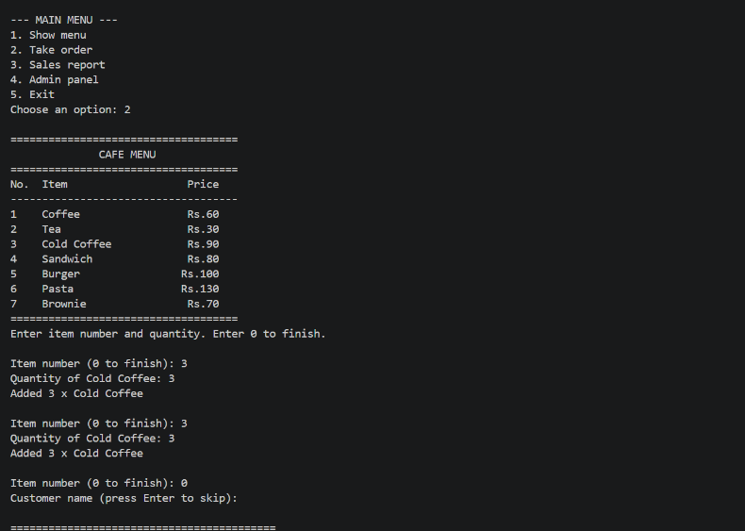
Figure 1. Supplied reference screenshot containing the required report structure.

Sample Result – Main Menu
==============================
WELCOME TO PYTHON CAFE
==============================
--- MAIN MENU ---
- Show menu
- Take order
- Sales report
- Admin panel
- Exit
Choose an option:

Sample Result – Bill
==========================================
CAFE BILL
==========================================
Bill No : 1
Date : 30-09-2026 14:30
Customer: Guest
------------------------------------------
Item Price Qty Amount
------------------------------------------
Coffee 60 2 120
Sandwich 80 1 80
------------------------------------------
Subtotal 200.00
GST (5%) 10.00
TOTAL 210.00 ==========================================
Thank you! Visit again :)
Note: The bill values above are an illustrative example of the program's output format, not a claim about an actual transaction.

Testing Approach
Testing was planned around normal inputs, invalid inputs and data-loading conditions. Because the project is a console application, functional testing can be performed by running each menu option and checking the displayed result and saved JSON data.
Test Case | Input / Action | Expected Result
TC01 | Show menu | All current menu items and prices are displayed.
TC02 | Valid item number + quantity | Item is added to cart.
TC03 | Item number outside range | Program prints 'no such item' and asks again.
TC04 | Non-numeric quantity | Program prints an error and asks again.
TC05 | Quantity less than 1 | Program rejects the quantity.
TC06 | Valid order completed | Bill is generated with subtotal, GST and total.
TC07 | Wrong admin password | Admin panel is not opened.
TC08 | Add/change/remove item | Menu is updated and saved.
TC09 | Sales report after orders | Order count, revenue and item quantities are shown.
TC10 | Missing/invalid JSON file | Program falls back to defaults or starts with no valid orders.

Challenges Faced
- Handling invalid user input without crashing the program.
- Keeping menu and order data available between program runs.
- Checking that loaded JSON order records contain the required fields.
- Keeping billing calculations consistent for multiple items and quantities.
- Managing the relationship between the cart, bill items and saved order records.
- Designing a simple admin flow while keeping customer ordering straightforward.
- Formatting the bill so item name, price, quantity and amount remain readable in the console.

Learnings & Key Takeaways
- Learned how to divide a Python program into small reusable functions.
- Practiced dictionaries and lists for representing menus, carts and order records.
- Learned how to read and write structured data using JSON.
- Understood basic input validation and exception handling with try/except.
- Practiced file handling using os.path.exists() and open().
- Learned how billing calculations can be automated using program logic.
- Understood how a simple sales report can be calculated from stored order data.
- Learned the importance of separating customer features, admin features and storage logic.

Future Enhancements
- Replace JSON files with SQLite or another database for larger data volumes.
- Use password hashing instead of storing the admin password directly in source code.
- Add a graphical or web interface for easier use by cafe staff.
- Add customer phone number, table number and order status.
- Add printable or PDF bill generation.
- Add date-wise, monthly and item-wise sales analytics.
- Add discounts, coupon codes and multiple GST/tax categories.
- Add inventory/stock management and automatic low-stock alerts.
- Add user roles such as cashier and manager.
- Add backup and restore for cafe data.

Conclusion
The Python Cafe Management System demonstrates the complete flow of a small business application: input collection, validation, calculation, billing, administration, file storage and reporting. Its modular structure makes it suitable as a beginner-to-intermediate Python academic project and provides a clear base for future database and GUI/web improvements.

